Cronin Assignment 3

QA1. What is the difference between SVM with hard margin and soft margin?’

The difference between SVM with hard margin and soft margin is the cost parameter. With hard margin, the cost factor is infinity, and no constraints are allowed to be violated. This means that all data points will be correctly sorted. This also means that the margin tends to be small. Soft margin allows for some misclassifications of data points so that the margin will be larger. To soften the margin, the cost parameter is lowered from infinity to a smaller number.

QA2. What is the role of the cost parameter, C, in SVM (with soft margin) classifiers?

The cost parameter decides the slack that will be allowed on the classifiers. For example, a cost parameter of 0 means that lots of slack is given and many constraints can be ignored. In this scenario, the objective is for the classifier to find the largest margin. A higher cost parameter means that fewer constraints will be violated, and the classifier works to do a better job on the training set.

QA3. Will the following perceptron be activated (2.8 is the activation threshold)?

No, the perceptron will not be activated.

(0.1\*0.8)+(11.1\*-.2) = -2.14

This is not higher than the activation threshold, therefore the Z=0 and it will not be activated.

QA4. What is the role of alpha, the learning rate in the delta rule?

The learning rate/alpha determines how fast the weights should be changed. A high learning rate means that the weights are changed dramatically, which can adapt fast but be instable. A low alpha/learning rate means that the weights are changed more gradually and smoothly. A lower learning rate is better at finetuning the weight in the delta rule.

LINK TO GITHUB WHERE R FILES ARE STORED: <https://github.com/hcroninkent/hcronin/tree/main/MIS64037>

QB1. Build a linear SVM regression model to predict Sales based on all other attributes ("Price",

"Advertising", "Population", "Age", "Income" and "Education"). Hint: use caret train() with

method set to “svmLinear”. What is the R-squared of the model?

The R-Squared for this model is 0.3675.

QB2. Customize the search grid by checking the model’s performance for C parameter of 0.1,.5,1 and 10 using 2 repeats of 5-fold cross validation.

The C parameter of 0.1 produced the best results.

QB3. Train a neural network model to predict Sales based on all other attributes ("Price",

"Advertising", "Population", "Age", "Income" and "Education"). Hint: use caret train() with

method set to “nnet”. What is the R-square of the model with the best hyper parameters (using

default caret search grid) – hint: don’t forget to scale the data.

The R-square value is 0.3806.

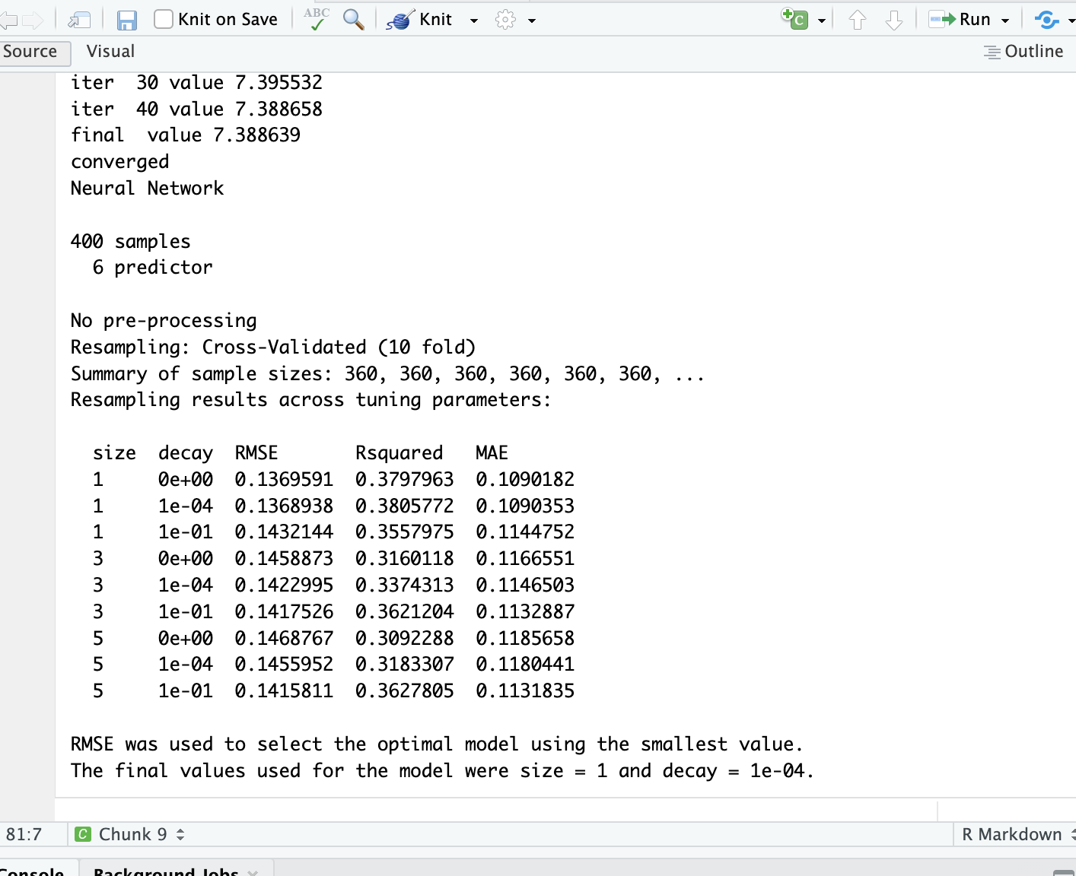

QB4. Consider the following input:

• Sales=9

• Price=6.54

• Population=124

• Advertising=0

• Age=76

• Income= 110

• Education=10

What will be the estimated Sales for this record using the above neuralnet model?

I used the model and the predict function and got a value of 0.2915. This values seems low.